Data on over 4,000 Kickstarter projects was provided for analysis. The dataset included funding goals and outcome (pledged money as well as ultimate disposition of the project). In addition, categories were assigned to each project for use in analysis.

We can make observations and conclusions based on our analysis of the data. First, there does appear to be a strong correlation between the funding goals (based on size) and outcome. Specifically, a higher percentage of projects were funded at the lower goal amounts (and a much lower percentage at the high end of the goals). We can see that trend in the graph below:

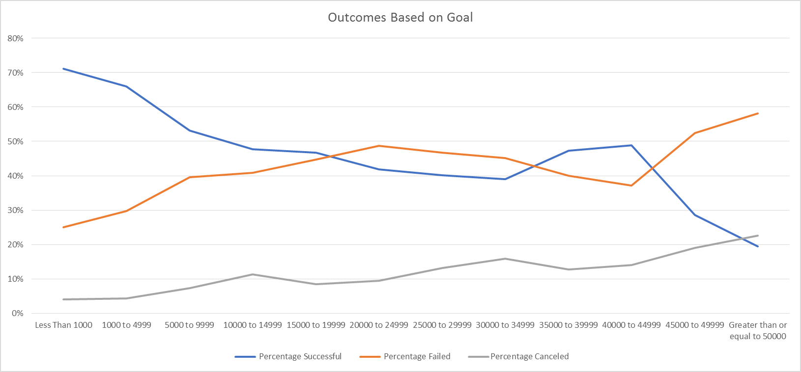

Second, if we look at the data by category, a few observations can be made. While the Theater category had the most successful campaigns, it also had – by far – the most submissions. The Music category was the most successful from a percentage basis and was also a very popular category. Finally, no Journalism campaigns were funded – all were cancelled.

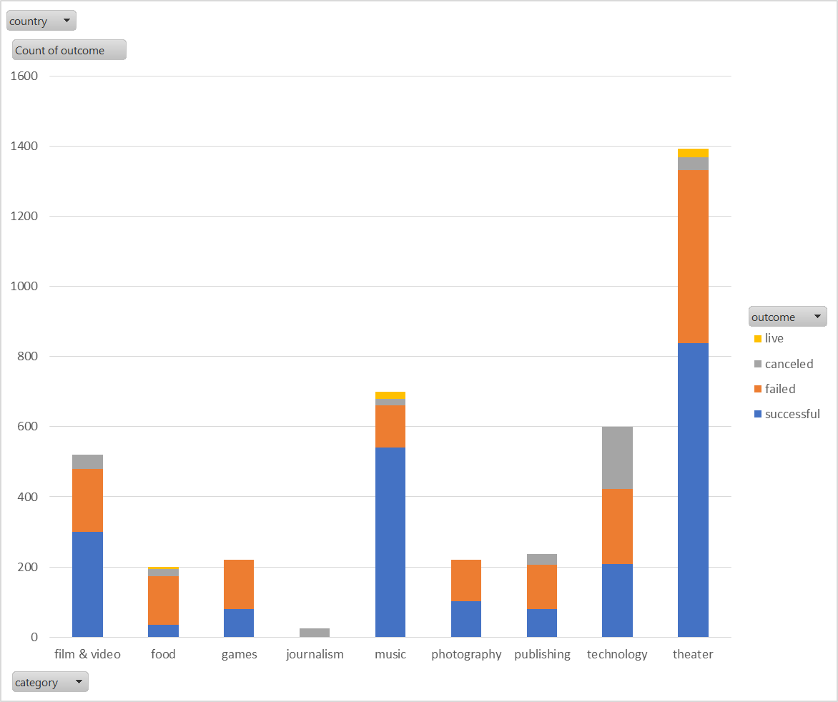

If we further divide the data into sub-categories, we can make some additional observations. The Play sub-category was, by far, the most popular. And it was funded at an above-average rate. There were a few other sub-categories that, while not popular in number, were funded at a 100% rate. Those included Rock, Documentary, and Hardware as well as numerous other smaller sub-categories.

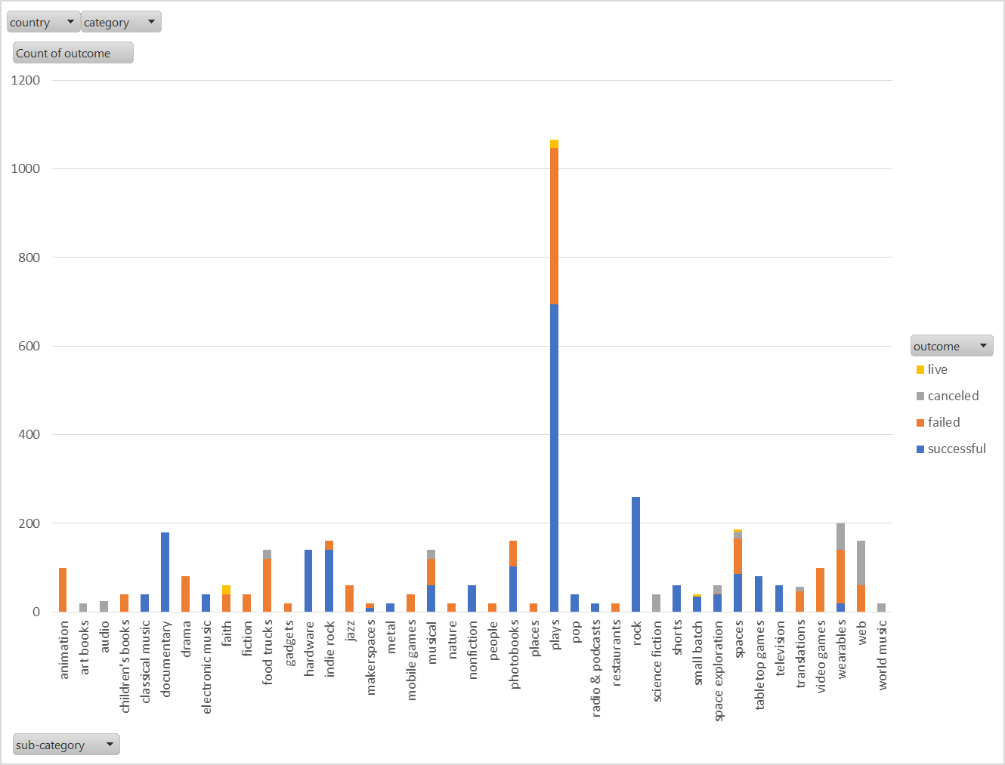

As we look at the Kickstarter data and try to draw conclusions, one piece of information that would be extremely useful in trying to predict what projects will achieve funding status would be a measure of the quality of the proposal. While certain categories and sub-categories tended to have a higher success rate, it would be very interesting to try to assess the quality of the proposal and its impact on funding success. It would be reasonable to assume potential investors would be more likely to support a project if the proposal was professional, thorough, and realistic versus something that looked poorly thought out or researched. It is not clear, however, how one could measure quality. A first-pass metric that would be interesting to examine would be the length of the proposal (with the supposition that a longer write-up would suggest – though not absolutely guarantee – higher quality).

Another analysis that might be interesting would be to look at all the funded projects and assess their “success” with use of the funds. Did Kickstarter users fund good projects? Or was their money wasted? Also of interest would be an assessment of any of the projects that did not get funded – i.e., did they find other ways to launch their project and was it successful. I believe this would be extremely difficult to acquire efficiently, so is probably not practical.

There are certainly other ways we could analyze the existing data. One idea might be to look at the average donation size versus outcome. A hypothesis would be that larger average donations would suggest a higher enthusiasm level and would translate to greater funding percentage. Another way to examine would be to look at the window for funding (the delta between launch and close). Did having more time result in greater success rate? Or were projects either enthusiastically supported to start or never at all? I would hypothesize that having a larger time window would not result in greater funding success -- but it would be interesting to see what the data shows.

Overall this was an interesting look at the Kickstarter data.